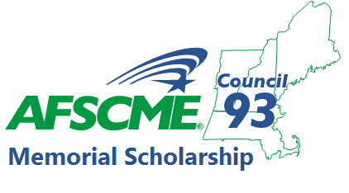
AFSCME Council 93 is proud to announce its
24th Annual Council 93 Memorial Scholarship
In 2021, the program will award five individuals $1,000 scholarships to students enrolled in a two-year or four-year accredited college.
Scholarships are renewable for each year of attendance with yearly proof of enrollment.
ELIGIBILITY:
- Open to Council 93 members and their spouses, children, stepchildren, grandchildren, or legal dependent. (Proof of AFSCME membership required)
- Acceptance into or already attending an accredited college or university, community college or recognized technical or trade school at the time of the award. Graduate students are not eligible.
- Only one application will be accepted per individual.

DEADLINE DATE:
- Applications and essays must be received by July 1, 2021. Please send to:
AFSCME Council 93 Scholarship Committee
8 Beacon Street
Boston, MA 02108
Or by email: aowen@afscme93.org

- Winners will be notified by July 30, 2020. The scholarship awards will be made at the AFSCME Council 93 Conference Banquet.

AWARD CRITERIA:
- $1,000 scholarship awarded each year for a two-year or four-year accredited college.
Proof of enrollment must be submitted to AFSCME Council 93’s Business Office by July 1st of each school year.
- Applicants must submit a typewritten, double-spaced essay based on the prompt: “Unions have been important to my family because…” The essay must be 500 to 750 words. The Scholarship Committee suggests that students contact their parents, grandparents, aunts, uncles, neighbors or friends to learn what labor union membership and participation may have meant to them. Union members are encouraged to discuss the essay with their children, grandchildren and others, in order to share their own experiences as possible topics for the essay.
- The Scholarship Committee will determine the award based upon the essay and completed application form. Upon receipt of each scholarship application, the applicant’s name and local number will be separately indexed. Once completed, the Scholarship Committee will then obscure this information to assure complete impartiality. The decision of the Committee is final.

