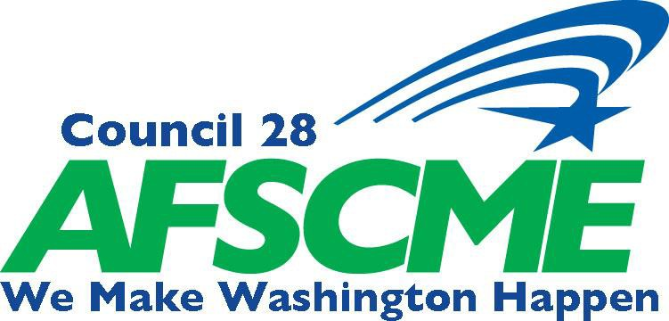

**Payroll & Benefits Specialist**

Olympia, WA

**Who We Are:**

The Washington Federation of State Employees (WFSE) has a long history of fighting for workers’ rights and employee benefits while tackling social justice issues with passion and energy. The WFSE, Council 28 has been operating in the state capital for over 77 years and our staff fight for fairness and equality as well as ensuring the hard working people of state government, higher education institutions, and public service workers get better pay, better health care, better retirement, and a healthy work environment. There’s more to accomplish, and with the right personnel, we believe we can accomplish it. Come join our team and be a part of a larger mission that will make an impact for years to come. Learn more about who we are at: [wfse.org](http://wfse.org/).

**What We’re Looking For:**

The Washington Federation of State Employees (WFSE) is recruiting to fill a Payroll & Benefits Specialist

position located in Olympia, WA. The Payroll & Benefits Specialist is an integral part of the payroll team assisting with daily functions such as spreadsheet support, accounts payable, new employee data input, set-up in payroll systems and entering new employee benefits while ensuring confidentiality and data integrity.

This position works closely with the Finance Manager regarding employee set-up into various databases that track employees work hours, leave, and benefits. Helps resolve inquiries regarding employee payroll issues and medical benefits and is responsible for entering employee benefits into various databases ensuring all documents are submitted to the appropriate agency.

Additional duties include:

* Reviews highly confidential information, maintains strict confidentiality, and is required to maintain database certification for data entry.
* Reconciles accounts and adjusts irregularities.
* Ensures compliance with the Affordable Care Act, payroll, leave and expense policies for staff and members.
* Processes payroll for permanent, temporary and on-call staff and member time loss activities.
* Assists with dues processing as needed.
* Ensures compliance with organization payroll/leave and expense policies for staff and members.

**Required Qualifications:**

* Has at least two (2) years’ experience in an accounting setting assisting with common accounting functions using Microsoft Excel and ADP, administrative work, and/or employee benefits administration.
* Knowledge and experience in office machines, Microsoft Office Suite, business management practices, and research methods.
* Highly organized and capable of juggling multiple projects simultaneously.
* Strong oral and written communication skills.

**Desirable Qualifications:**

* Is educated in, or has experience with labor unions and basic personnel practices.

**Special Note:**

WFSE is complying with the federal mandate that all employers of 100 employees or more are required to be vaccinated against COVID-19. *As such, candidates who are offered a position will be required to submit proof of vaccination to the Human Resources Office prior to the start of employment.* This position is overtime eligible and may be required to work some weekends. Some travel may be required. Benefits include annual and sick leave, cell phone allowance, medical/dental, life, and long term disability insurance, and holidays. Salary range is $55,343 to $64,066 and will be determined commensurate with experience.

**How to Apply:**

To be considered for this position(s), applicants must submit a resume, letter of interest, and at least three (3) professional references to: [resumes@wfse.org](mailto:resumes@wfse.org). Your letter of interest should clearly explain how your experience, training, and education make you a viable and competitive candidate for this position.

***This position is open until filled; however, the hiring authority may conduct interviews as soon as qualified candidates apply. It is to the applicant's advantage to apply as early as possible.***

The Washington Federation of State Employees is committed to providing equal employment opportunity and equal access in a non-discriminatory manner to its programs and services for all persons without regard to race, creed, color, marital status, gender, sexual orientation, religion, age, national origin, political affiliation, honorably discharged veteran or military status, or the presence of any real or perceived sensory, mental, or physical disability.  
   
Persons requiring accommodation in the application process or for an alternative format may contact the Human Resources Director, Ben McDonald at (360) 352-7603 or [benm@wfse.org](mailto:benm@wfse.org). Persons of disability or those who are deaf or hard of hearing can call the Washington Relay Service by dialing 7-1-1 or 1-800-833-6388. The WFSE complies with the employment eligibility verification requirements of the Federal Form I-9. The selected candidate must be able to provide proof of identity and eligibility to work in the United States consistent with the requirements of that form on the first day of employment.